**ASSIGNMENT 2:**

Create a git repository with three branches 2023Q1, 2023Q2, 2023Q3 each branch has its own index.html file. Create 3 jobs for three branches, run each job and website should be deploy on our httpd server with different code for different job, Using Jenkins Pipeline Job.

**Step 1:** Set-up Jenkins master server

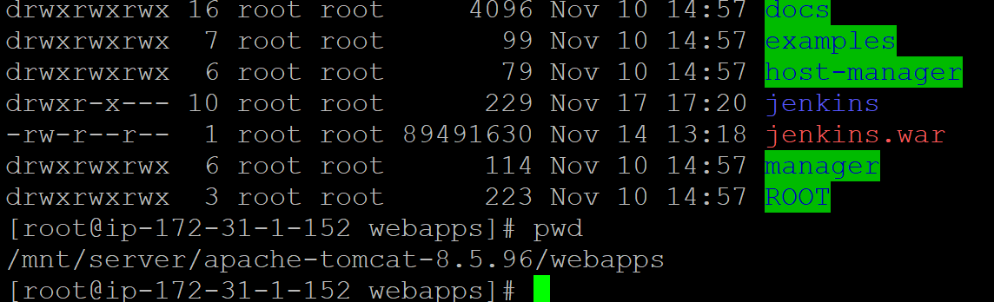

**Step 2:** git repository with 3 different branches- 23Q1, 23Q2, 23Q3

**Step 3:** Created 3 different pipeline jobs in Jenkins:

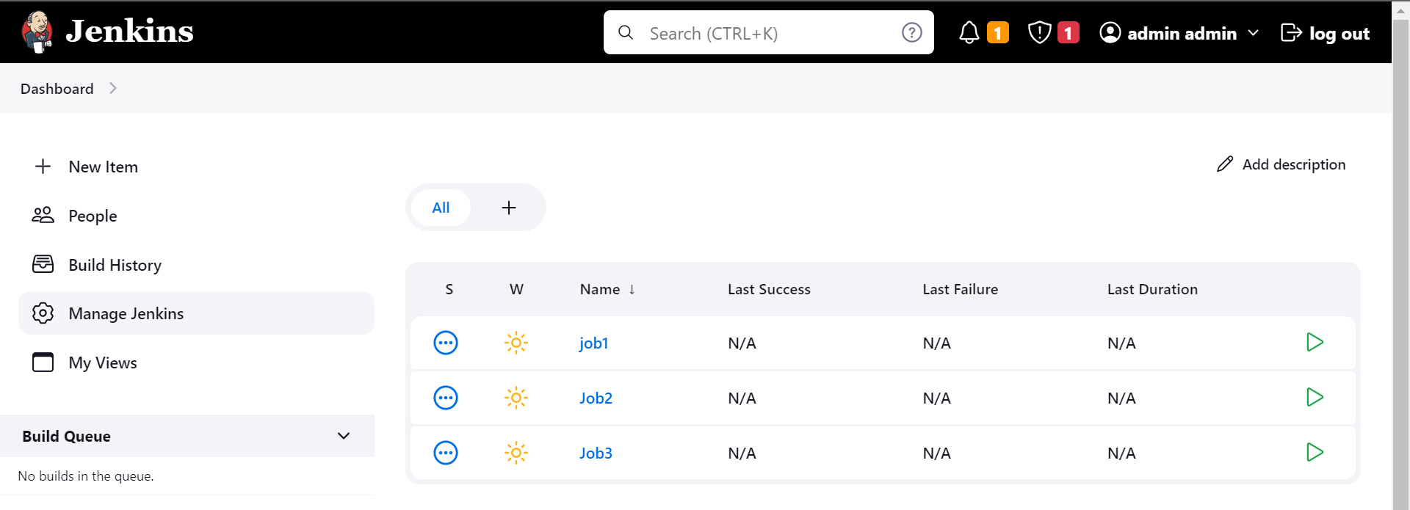

**SCRIPT FOR JOB 1:**

|  |
| --- |
| pipeline{      agent{          label{              label "built-in"              customWorkspace "/mnt/workspace"          }      }      stages{          stage("httpd-server"){              steps{                  sh "sudo yum install httpd -y"                  sh "sudo service httpd start"              }          }          stage("git-clone"){              steps{                  git branch: '23Q1', changelog: false, credentialsId: 'git-token', poll: false, url: 'https://github.com/pskarne/multi-branch.git'              }          }          stage("deploy-index.html"){              steps{                  sh "sudo chmod -R 777 /var/www/html/"                  sh "cp -r index.html /var/www/html/"              }          }      }  } |

**SCRIPT FOR JOB 2:**

|  |
| --- |
| pipeline{      agent{          label{              label "built-in"              customWorkspace "/mnt/workspace"          }      }      stages{          stage("httpd-server"){              steps{                  sh "sudo yum install httpd -y"                  sh "sudo service httpd start"              }          }          stage("git-clone"){              steps{                  git branch: '23Q2', changelog: false, credentialsId: 'git-token', poll: false, url: 'https://github.com/pskarne/multi-branch.git'              }          }          stage("deploy-index.html"){              steps{                  sh "sudo chmod -R 777 /var/www/html/"                  sh "cp -r index.html /var/www/html/"              }          }      }  } |

**SCRIPT FOR JOB 3:**

|  |
| --- |
| pipeline{      agent{          label{              label "built-in"              customWorkspace "/mnt/workspace"          }      }      stages{          stage("httpd-server"){              steps{                  sh "sudo yum install httpd -y"                  sh "sudo service httpd start"              }          }          stage("git-clone"){              steps{                  git branch: '23Q3', changelog: false, credentialsId: 'git-token', poll: false, url: 'https://github.com/pskarne/multi-branch.git'              }          }          stage("deploy-index.html"){              steps{                  sh "sudo chmod -R 777 /var/www/html/"                  sh "cp -r index.html /var/www/html/"              }          }      }  } |

**Successfully executed Job1, Job2 & Job3:**

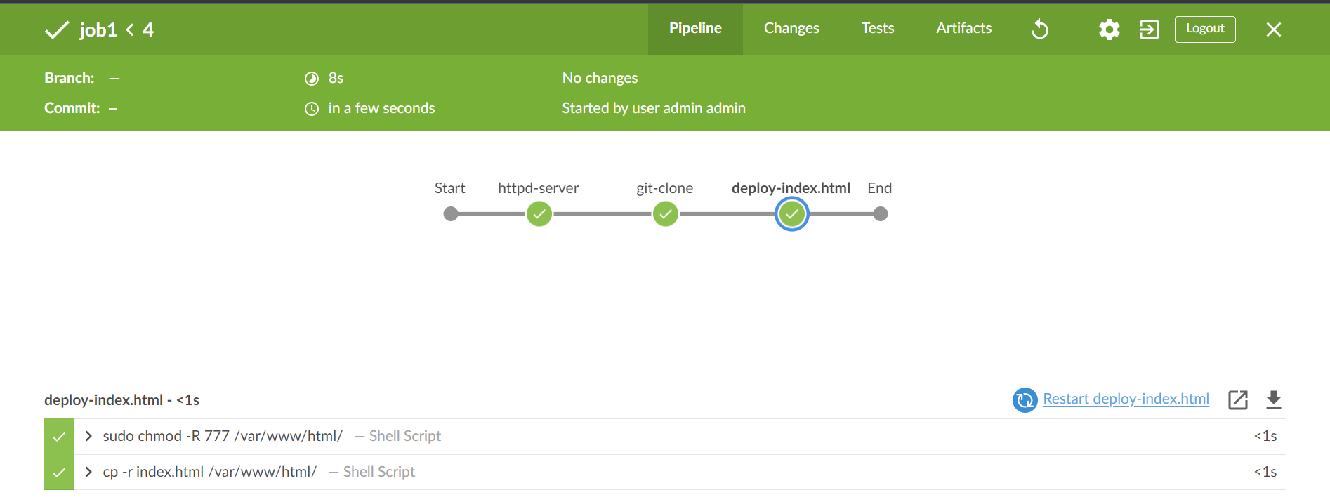

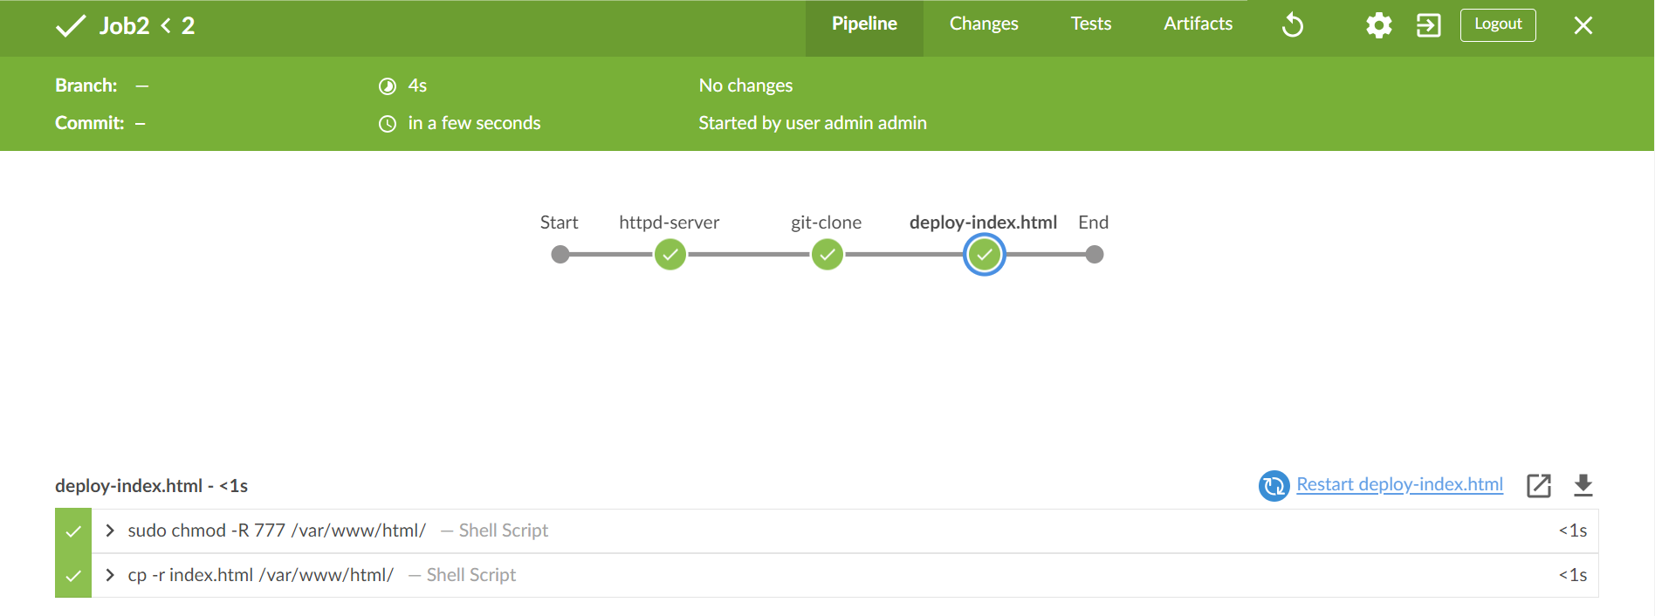

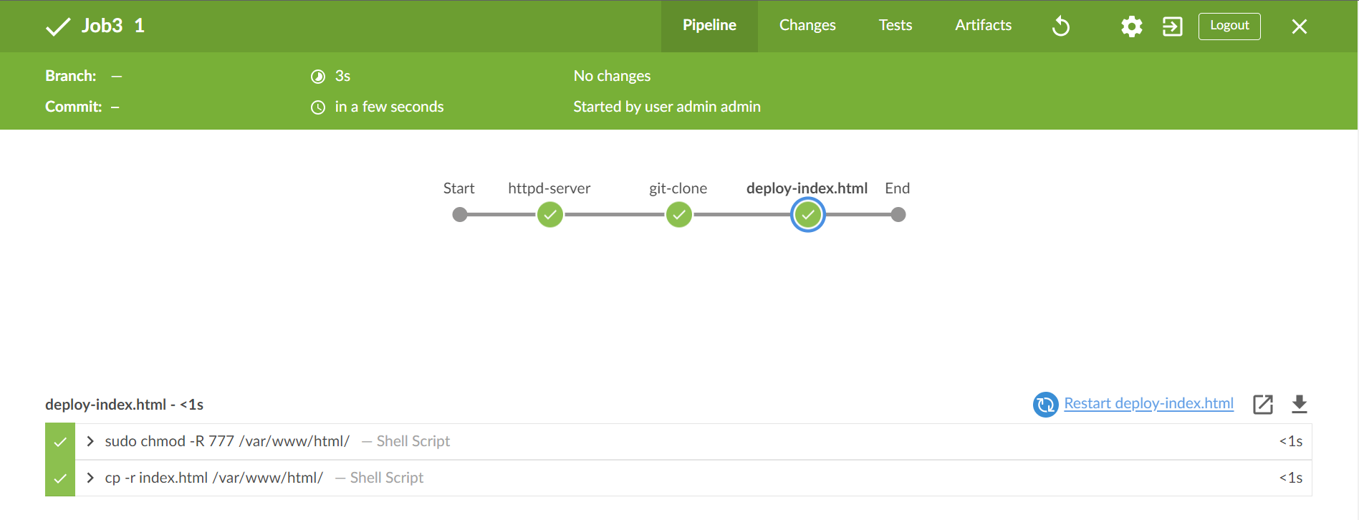

**-: OUTPUT :-**

**After running Job 1**

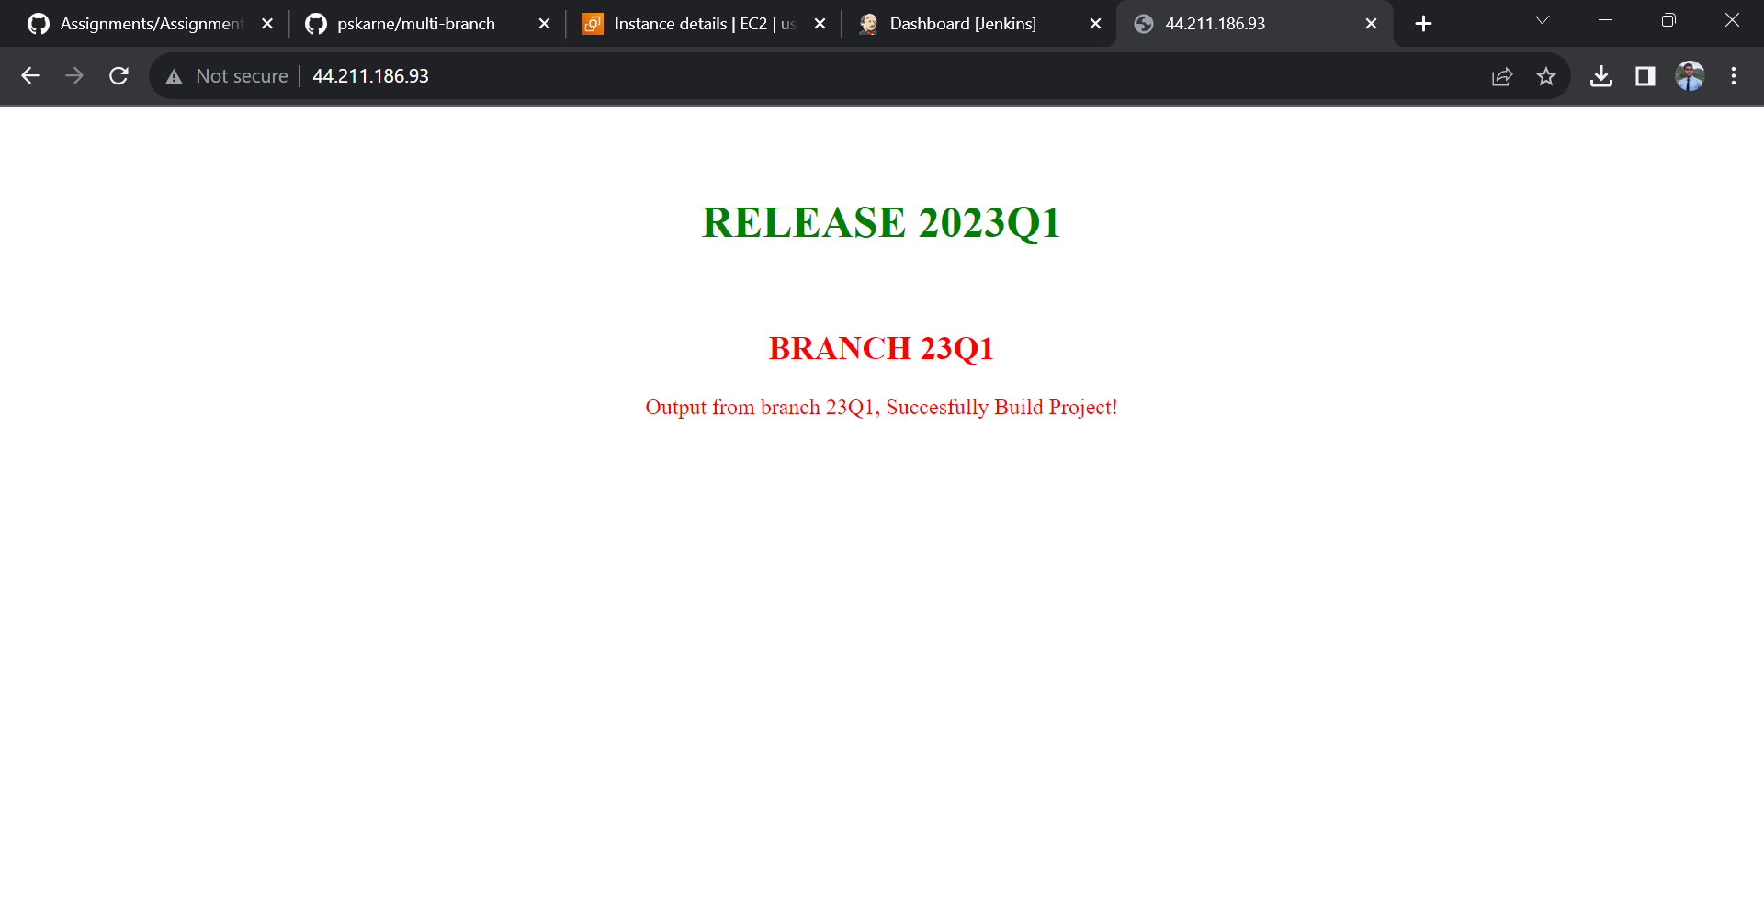

**After Running Job 2:**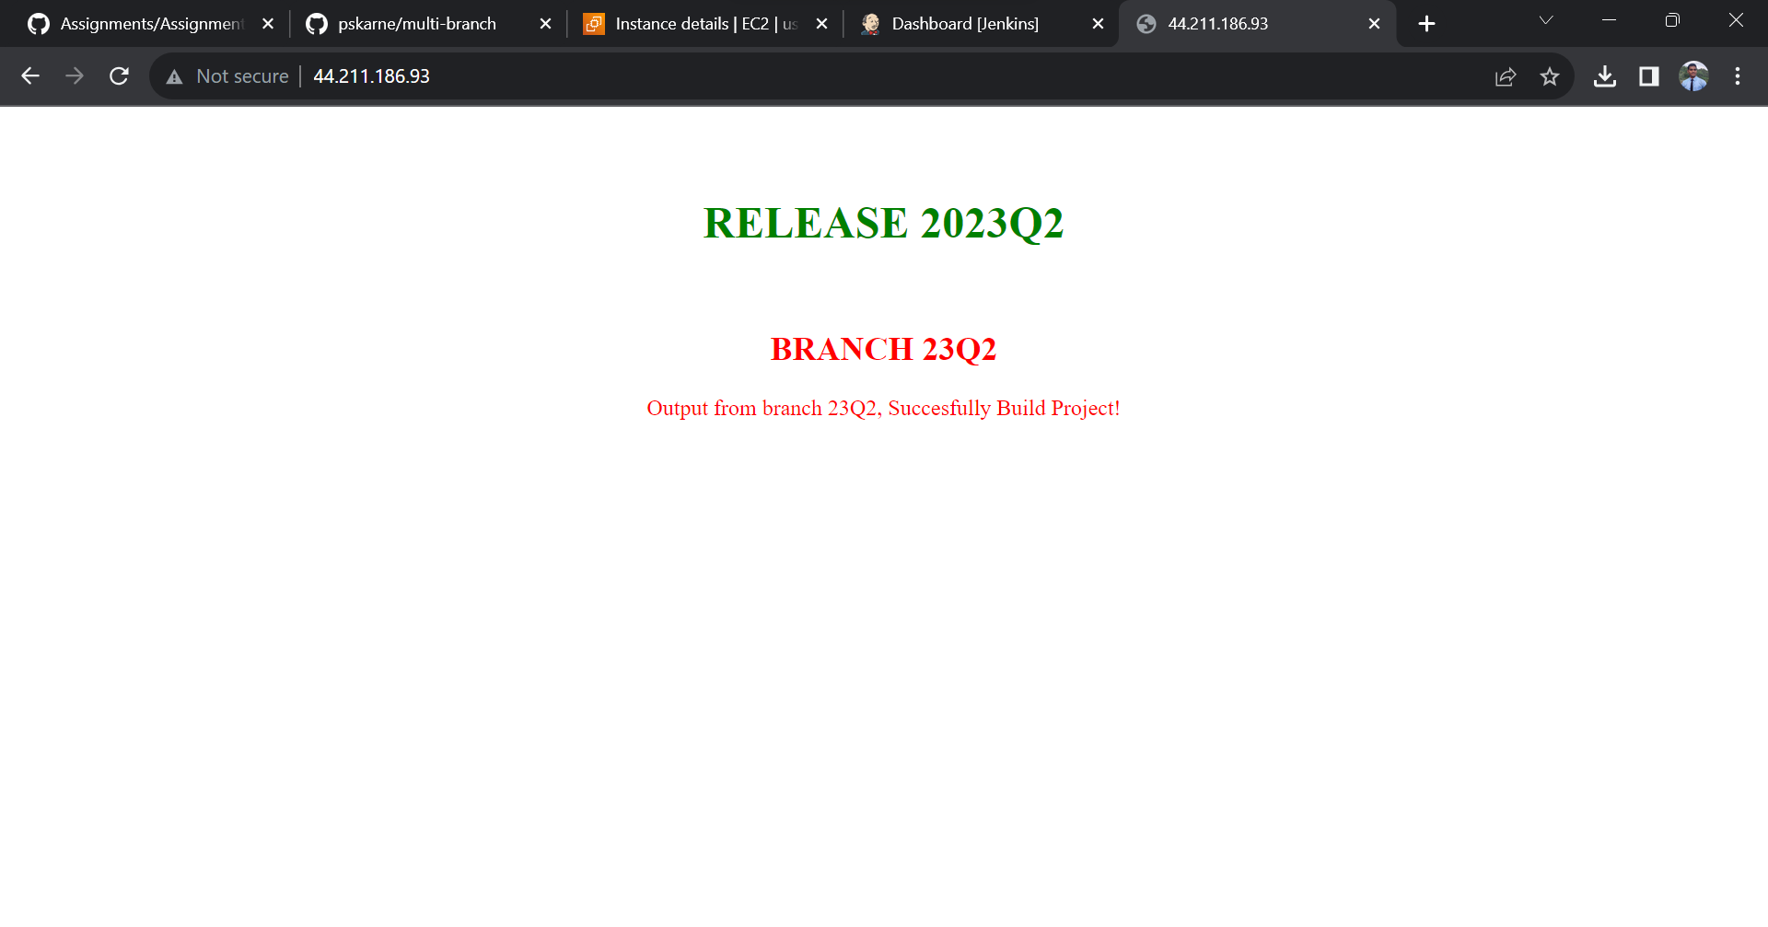

**After Running Job 3:**

